_{King Saud University}
College of Computer and Information Sciences
Department of Software Engineering

Assignment 1

Due Date: Sunday, March 26, 2017

STUDENT OUTCOMES: This assignment covers the following student outcomes (SOs):
- SO (l): The ability to analyze, design, verify, validate, implement, apply, and maintain software systems.

 | TOTAL
SO (l) | /5

FEEDBACK SUMMARY:
………………………………………………………………………………………………………
………………………………………………………………………………………………………
………………………………………………………………………………………………………

STUDENT IDENTIFICATION:

Name: ………………………………….. ID: ……………………

PLEASE NOTE:
- The assignment contains 5 sheets.
- Hand-written solutions will not be accepted.
- You should use Rational Software Architect to draw the use case diagram.

Consider the Restaurant Online Booking System (described in pages 4-5):

- Provide the following:
  - A list of two functional requirements.
  - A list of two nonfunctional requirements (must be measurable).
  - A list of two design constraints.
- Draw the use case diagram. Only include a total of eight use cases along with their related actors. You must use an ‘includes’ and an ‘extends’ relationships.
- Provide the description for the “Make a Booking” use case. The use case describes how a customer can use the system to book a table in Mr.Pascal’s restaurant. Include three alternative flows only. You must write a pre-condition and a post-condition. Fill the table provided in the next page.

Restaurant Online Booking System

In this project, your team of analysts will work on specifying the requirements and use case model for a new system requested by Mr.Pascal for his restaurant to help manage table bookings.
Mr Pascal is the owner and manager of the restaurant ‘Pascal’s’. This is a popular French restaurant, with a lot of repeat trade, which is busy most evenings and full at weekends. The restaurant is only open in the evenings and seats 50 customers with only one service per night.
Currently all bookings are received over the telephone. On answering the call, Mr Pascal always requests the required date and the number of guests to be seated. He then checks to see if the booking can be accommodated. Where the booking can be accommodated, he asks the customer for further booking details including the booking name, contact number and number of people in the booking. He then logs the booking into the restaurant diary under the relevant date.
Mr Pascal also asks whether there are any special dietary requirements or whether the booking is for a special occasion such as birthday or anniversary, so he can arrange for birthday cakes, balloons etc.
Mr Pascal always reads the details he has taken back to the customers so that they can confirm their bookings.
If the restaurant is full on the required evening, Mr Pascal offers an alternative date for the booking or, if this is not acceptable, asks if the customer would like to be added to a waiting list. The waiting list is recorded at the bottom of each page in the diary and a contact name & number along with number of people in the booking is taken. This enables Mr Pascal to view bookings regularly and manage changes to bookings should someone cancel or change their booking.
On a daily basis the Head Chef, Jacques, will check the diary to see if there is any special dietary requirement he needs to be aware of that day. Francoise, the Head Waiter, also prints the diary each day in order to draw up a table plan for each service.
As the restaurant is so busy Mr Pascal would like to start opening lunch times but currently the telephone bookings are taking up too much of his time. Further, Mr Pascal has received feedback from his customers that they cannot sometimes get through to book as the phone line is busy. In response to this, Mr Pascal has decided to invest in an on-line booking system that would enable customers to make reservations on-line. Since the restaurant is so popular, Mr.Pascal wishes to launch the system as soon as possible.
Mr Pascal is keen that the new system does as a minimum what his current restaurant diary enables him and his staff to do. The hope is that this will reduce the telephone calls as well as provide an alternative method of booking at his restaurant which has been requested by for his loyal customers. For flexibility, customers should be able to manage their bookings easily, either cancel or change their booking. The system is expected to send a confirmation email to the customer once a booking is made.
It is envisioned that the system is able to run on both apple and android phones/tablets. It should have a simple interface and easy to use. Also, the system shall support a large number of users accessing the system at the same time. The system should be available most of the time.

************************************************************************

Two Functional Requirements:
- Customer should be able to make a booking.
- Customer should be able to cancel booking.

Nonfunctional requirements:
- The system shall support a large number of users accessing the system at the same time (should be able to handle more than 100 requests at the same time).
- The system should be available most of the time(working ok 99.99% of the time).

Two Design Constraints:
- The system is able to run on both apple and android phones/tablets.
- For flexibility, customers should be able to manage their bookings easily.

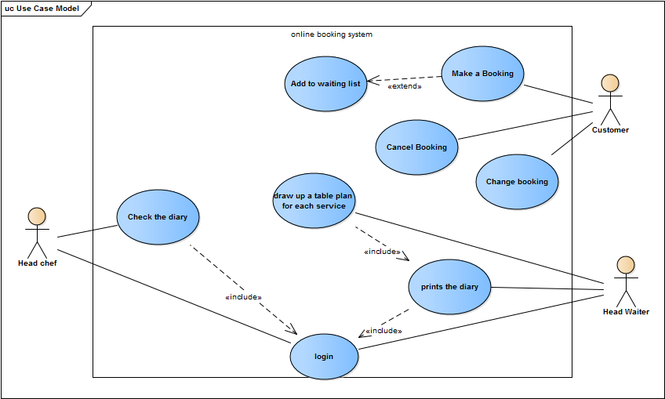

Use Case Description
System: Restaurant online booking system
Use Case name: Make Booking
Primary actor: Customer | Secondary actor(s):
Description: this use case let the customer to create a booking in the restaurant.
Relationships
- Extends: Add to waiting list
Pre-conditions:
Steps:
Primary Actor (Customer) |  | System
- Customer enters booking information (booking name, contact number, number of people in the booking, booking date, special dietary requirements).  - Customer enters the reason of booking.  - Customer presses confirm button |  | - system checks the validity of date, if it is valid then system asks customer to choose the reason of the booking.  2.1 system adds the reason to database then checks the reason.  2.2 system display booking information with a "confirm" button.  3.1 system adds the booking to database.  3.2 system displays success message.
Alternative and exceptional flows:

1.1 if booking date is not available then system display "error" message and asks customer to change date, if customer didn't change then extends to <<Add to waiting list>>
2.1 If reason is for special occasion then system display contact numbers to reserve cake and other things.
Post-conditions: a booking is been made for a customer.

